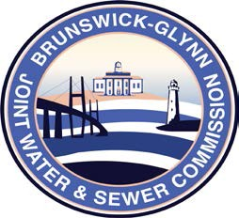

**Brunswick – Glynn**

**Joint Water & Sewer Commission**

February 7, 2020

Bid Award

**PROJECT: INVITATION FOR BID NO. 20-024 ACADEMY CREEK WAREHOUSE ROOF REPLACEMENT AND REPAIR**

At the February 6, 2020 regular meeting of the Brunswick-Glynn Joint Water & Sewer Commission, the contract for IFB No. 20-024 Academy Creek Warehouse Roof Replacement and Repair was awarded to:

ROOFING PROFESSIONALS, INC.